/*Find the item that has minimum weight.*/

select * from items order by weight limit 1;

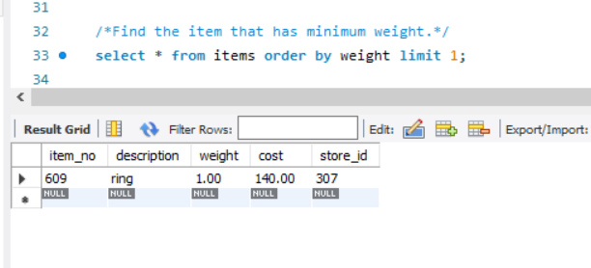

/*Find the different warehouses in “Pune”. */

select warehouses.wname, cities.city

from warehouses

inner join cities

on cities.city_id = warehouses.city_id

where cities.city = 'pune';

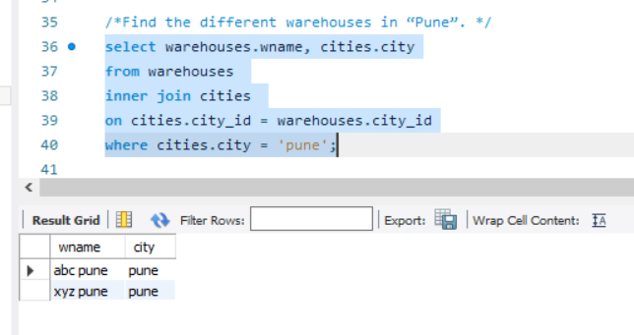

/* Find the details of items ordered by a customer “Mr. Patil”.*/

select customer.customer_name, customer.address, customer_order.order_no, items.description, items.weight

from customer

inner join customer_order on customer.customer_id = customer_order.customer_id

inner join order_item on customer_order.order_no = order_item.order_no

inner join items on order_item.item_no = items.item_no

where customer.customer_name='mr patil';

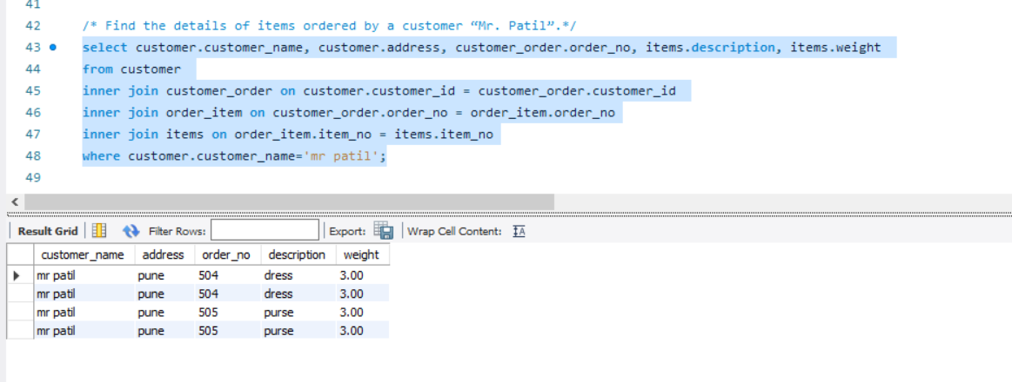

/*Find a Warehouse which has maximum stores. */

select warehouses.wid, warehouses.wname, stores.store_name, count(*)

from warehouses

inner join stores on warehouses.wid = stores.wid

group by wid

order by count(*) desc limit 1;

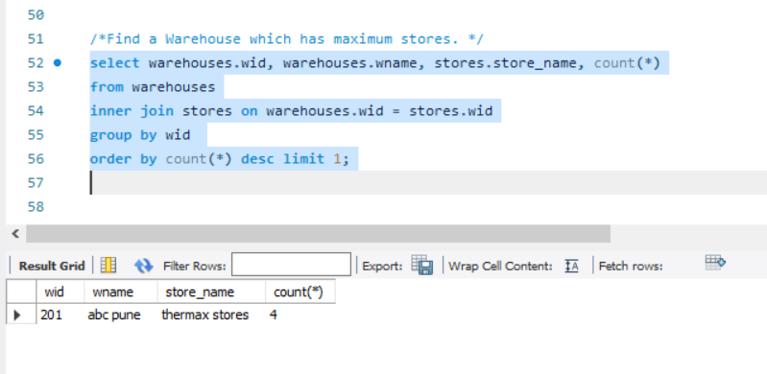

/* Find an item which is ordered for a minimum number of times. */

select customer.customer_name, customer.address, customer_order.order_no, items.description, items.weight, count(*)

from customer

inner join customer_order on customer.customer_id = customer_order.customer_id

inner join order_item on customer_order.order_no = order_item.order_no

inner join items on order_item.item_no = items.item_no

group by items.item_no

order by count(*) limit 1;

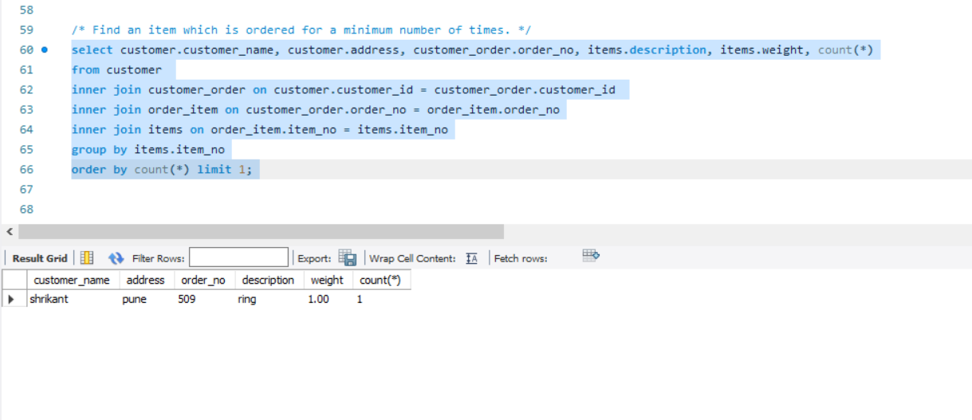

/*Find the detailed orders given by each customer.*/

select customer.customer_name, customer.address, customer_order.order_no, items.description, items.weight

from customer

inner join customer_order on customer.customer_id = customer_order.customer_id

inner join order_item on customer_order.order_no = order_item.order_no

inner join items on order_item.item_no = items.item_no;

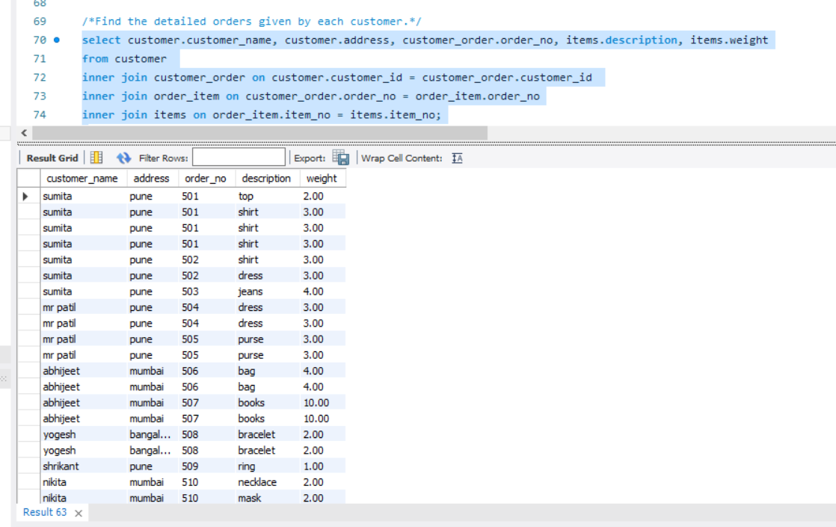s